Medium Article Analyzer

# Phase 1: MVP

## Agent Architecture

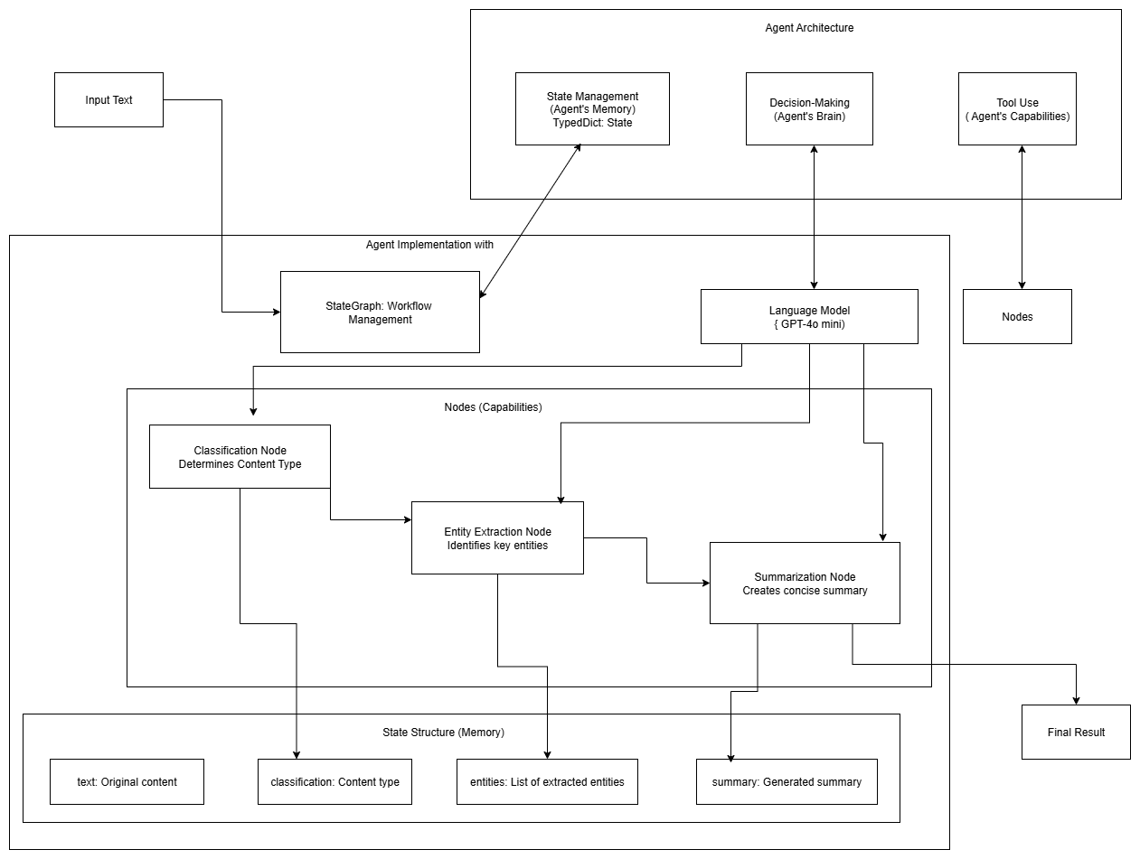

The MVP is basically a multi-node AI agent built with

1. LangGraph - Agent workflow orchestration
2. LangChain - LLM framework and prompt management
3. LLM - gpt-4o-mini - Language model for text processing
4. Python - Core implementation language

Key features:

1. Text Classification: Automatically categorizes text into News, Blogs, Research, and Other
2. Named Entity Recognition: Extracts people, organizations, and locations from text
3. Text Summarization: Generates concise one-sentence summaries
4. Workflow Orchestration: Uses LangGraph state management for coordinated multi-step processing
5. OpenAI Integration: Powered by GPT-4o-mini for reliable text analysis

The nodes in this MVP are:

1. Classification Node
2. Entity Node
3. Summarization Node

## Phase 2: Medium focused text analysis

requests + BeautifulSoup4 - for extracting article content